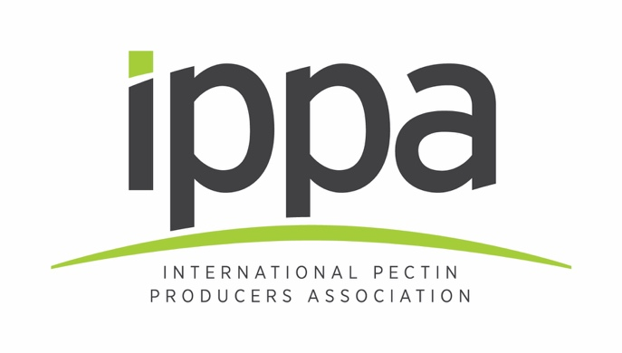

**13 February 2020**

**New IPPA Information Centre   
showcases pectin’s enduring relevance**

Members of the International Pectin Producers Association (IPPA) have joined forces to launch the Pectin Information Centre.

Available at **ippa.info**, the new industry-backed platform is set to become the ultimate source of knowledge about pectin, its provenance, its applications and technical and nutritional benefits in today’s food and beverage sector.

IPPA has also revitalized it’s 20-year old brand, unveiling a new, modern logo and house style to reflect pectin’s enduring relevance. Pectin is sourced from fruit, which means it is perfectly aligned with current consumer trends for foods and beverages that are produced with nature-derived and label-friendly ingredients.

The Pectin Information Centre offers a series of free, downloadable factsheets developed for a wide audience, from members of the public to students to industry professionals. Factsheets currently available cover topics including the molecular structure of pectin, how it is sourced and produced, its use in food and beverage products, and an overview of safety, labelling & regulatory matters. More are in development.

Susanne Sörgel, IPPA President, said: “Pectin is an ingredient with a huge amount of heritage, but it remains just as on-trend in 2020 as it was more than 250 years ago, when it was first used. With this in mind, IPPA has developed the Pectin Information Centre to help nurture a more widespread understanding of pectin’s functionality and how it can help companies formulate products that meet consumer demand for products with clearer labels that are easy to understand.”

**About IPPA**

IPPA is the International Pectin Producers Association. It represents the world’s leading pectin producers: Cargill, CEAMSA, CP Kelco, DuPont, Herbstreith & Fox, Naturex, JRS Silvateam Ingredients, DSM Andre Pectin and Dangshan Haisheng Pectin. IPPA promotes high standards within the pectin industry by:

* Co-ordinating dialogue with international bodies and national regulatory authorities
* Ensuring member companies are fully informed of changes in regulatory requirements as early as possible
* Sharing information on scientific and analytical techniques that could help member companies conform to high standards and meet regulatory requirements
* Encouraging scientific studies in areas of interest to the pectin industry and distributing the results of the latest research
* Promoting the use of pectin as a safe and effective ingredient in foods, beverages and other products

**ENDS**

**Press contact:**

Richard Clarke, Ingredient Communications

[richard@ingredientcommunications.com](mailto:richard@ingredientcommunications.com) | +44 (0) 1293 763004

***Visit ippa.info for more information***